You must include a written description of three observable trends based on the data.

As their Chief Data Analyst, you've been given access to the complete data from their most recent animal study. In this study, 250 mice were treated through a variety of drug regimes over the course of 45 days. Their physiological responses were then monitored over the course of that time. Your objective is to analyze the data to show how four treatments (Capomulin, Infubinol, Ketapril, and Placebo) compare.

Effect on Mortality:

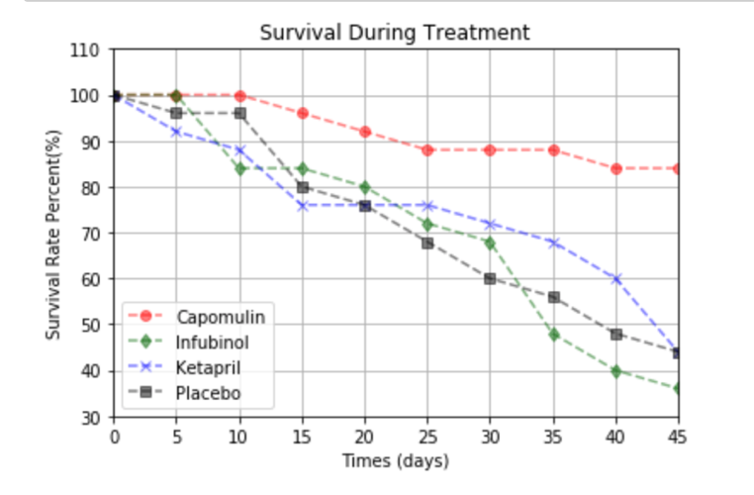

The group of mice receiving, Capomulin, had the highest rate of survival at around 85% while the other three groups of mice all had mortality rates lower than 50% after 45 days.

Effect on tumor size:

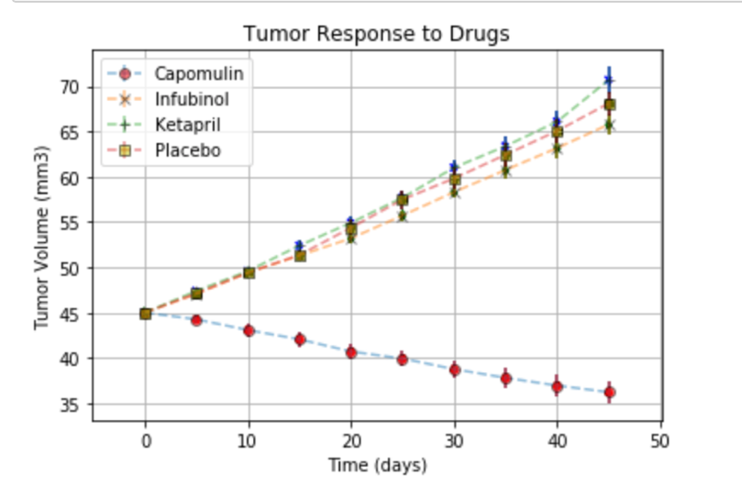

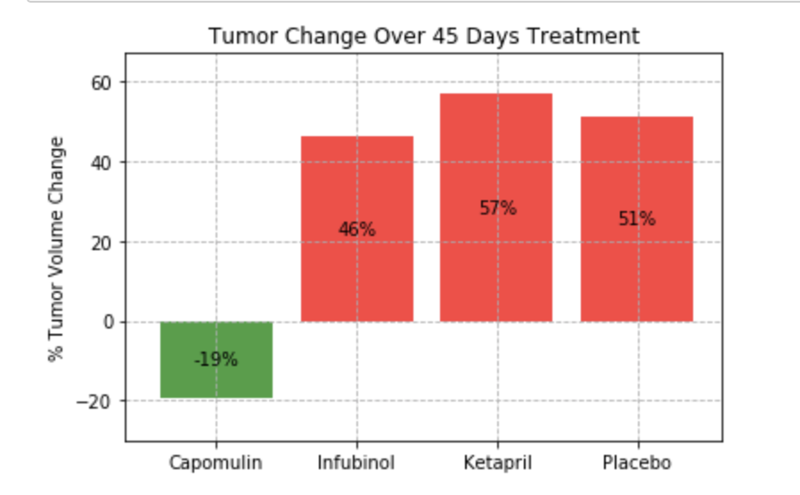

Mice treated with Capomulin experienced the only reduction in tumor size with tumor volume decreasing an average of 19% by end of the trial compared to growth in the three other groups.

Effect on Metastasis:

The average number of metastatic sites on mice receiving Capomulin was 1.5 compared to 3.3 metastatic sites for mice receiving the placebo/control.

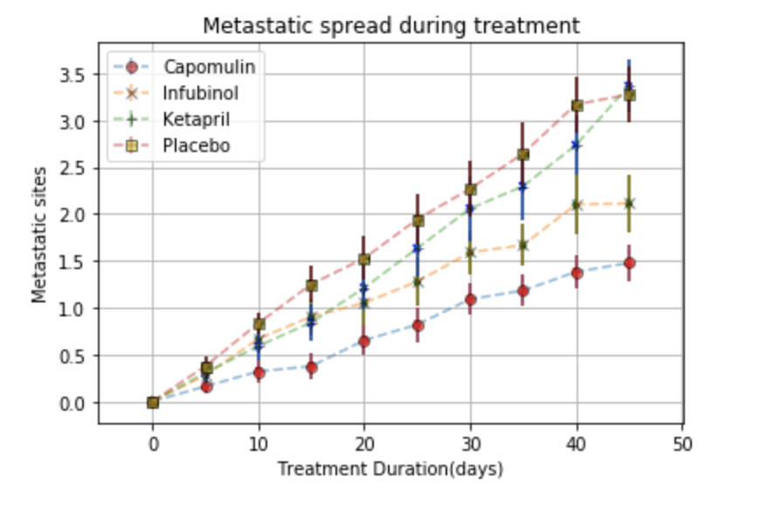

Conclusions:

Capomulin decreases the chance of death in mice with tumors, slows the spread of tumor metastasis, and can reduce the size of the tumor.